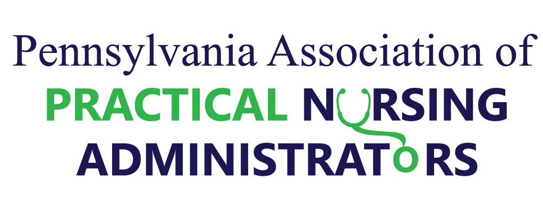
Resilience-Ability to Change Capacity to Recover
Success is not final, failure not fatal; it is the courage to continue that counts” (Winston Churchill 1874-1965)

Topics
PN Educators Best Practices
Classroom and Clinical Learning Strategies – PN Education Regulations Update
Recognition – Nurse Educator of the Year

Fa culty and Student Resilience Depends on Self Care by speaker from Nurse Tim.

Wednesday, May 6, 2020
8 a.m. – 4:30 p.m.
BEST WESTERN Country Cupboard
Lewisburg, PA

Registration through April 17, 2020, limited to 100 participants, early registration is encouraged. Send registration to Jenn Holzer, Prism Career Institute 8040 Roosevelt Boulevard Philadelphia, PA 19152 Call for availability after April 17 215-868-9465. No walk-in registration on day of conference.

NOTE: Hotel accommodations is a separate registration from this conference registration. Cost is $120 payable by check or money order payable to PA-PNA. 6.75 CEUs. Will be awarded.
Annual Faculty Development Conference
For PN Faculty and Administrators

Resilience-Ability to Change Capacity to Recover

May 2020 Faculty Development Conference
Registration
Best Practices for Nurse Educators, Share the Knowledge - Educators supporting Educators. Faculty and Student Resilience Depends on Self Care by speaker from Nurse Tim. CEUs provided by
PAPNA and
Wednesday, May 6, 2020
8 a.m. – 4:30 p.m.
Register by Friday, April 17, 2020

Name:
School:
Address:
City: Choose an item. Zip Code:

Phone: Email:

I am: ☐ Faculty ☐Administrator
I am attending:
☐ Faculty Development Conference Day, Wed, 5.6.2020 (cost $110)

☐ Faculty Networking Session, Tues, 5.7.19 (7-8 pm – free and optional)

Conference Cost - $120.00 by check, money order payable to “PA-PNA”. Send registration and money to Jennifer Holzer Prism Career Institute 8040 Roosevelt Boulevard Philadelphia, PA 19152 Late registration only if space available, no walk-in registration.

IMPORTANT: Best Western- Country Cupboard hotel registration is a separate registration.
--------------------------------------------------------------------------------------------------
ATTN: Nurse Administrators/Directors of PN Programs. Registration for PAPNA Administrators Conference May 7-8 is a separate registration form faxed/sent to Best Western directly. For best hotel rates register by April 17, 2020. Questions? Call or email –
Jenn Holzer PA-PNA President @ (215)868-9465 or Jholzer@prismcareerinstitute.edu

